**Student Enrollment Website week 4**

Michael Ward

University of Arizona Global Campus

CST499: Capstone for Computer Software

[Charmelia Butler](https://uagc.instructure.com/courses/120445/users/279676)

8/21/23

This is the Database showing the course enrollment. The first image I was still struggling to get the classID to populate based on the button clicked.

The second image shows where the classID is receiving data from the course enrollment.

This is the PHP code that runs the form to enroll into classes and will be used to add the student to the waitlist.

This is the Course List

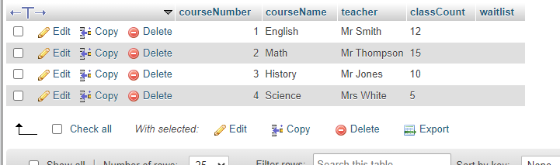

This is a screen capture of the user profile for students, this will be where courses and waitlists will be displayed and where students can drop classes if they desire.

SQL table of the User profiles that are currently set up as test accounts

